Integrate the Jira with this existing codebase - following mandatory details
Base Url - https://roshi8827.atlassian.net/
Endpoint - rest/api/3/search/jql
Jira API Key – ATATT3xFfGF0IXWR3Nw7wlR9dAohVwKcjzwoIQS-g-6UONWLO_q1UbmnitAcFsLlKBQguiHD45E0V5l01U0VeieWfrw0g65w5HlQh5MaFWVo5FmzZ1m5mgsRxiU2TdciypEAW5NzB1aSjmUZUNrHPqXdC41FSA9E2wekUjjzTF_bABHtflywGGk=1474607C

Generate API token in jira and pasted at basic auth password - 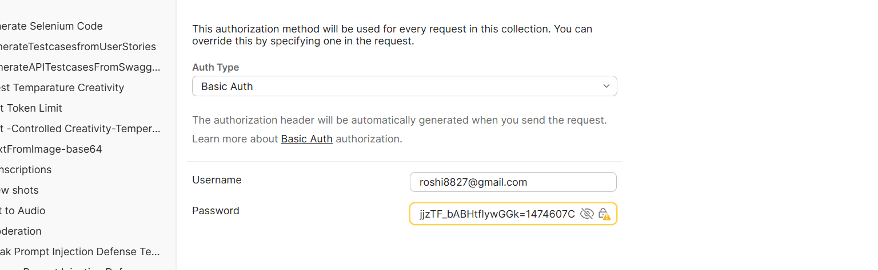
Hit the single story api call-
